# Kansas CTSOs

Career and Technical student organizations

## CTSOs: A Cornerstone of High Quality CTE Programs

### A logo with red and blue textBusiness Professionals of America (BPA)

National Leadership Conference | May 2024 | Chicago, IL

* Three (3) Kansas members placed first in the nation
* One (1) Kansas member placed second in the nation
* Six (6) Kansas members placed third in the nation
* 46 Kansas members placed in the top ten in the nation

2024 Membership – 691 | Chapters - 32

### DECA

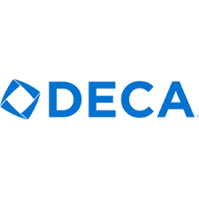International Career Development Conference | April 2024 | Anaheim, CA

* Kansas members from Blue Valley Northwest HS, Blue Valley High School, and Leavenworth High School were national finalists in the Start-Up Business Plan, Hospitality and Tourism Professional Selling, and Student Based Enterprise events

2024 Membership – 1377 | Chapters - 38

### Future Business Leaders of America (FBLA)

National Leadership Conference | June 2024 | Orlando, FL

* A Kansas member from Wellsville HS was elected as the National Mountain-Plains Regional Vice President
* Members from Blue Valley North earned 1st in the nation in the Financial Statement Analysis event
* A member from Wellsville HS earned 1st in the nation in the Job Interview event
* A member from Olathe South HS earned 1st in the nation in the Marketing event
* A member from Andover HS earned 2nd in the nation in the Intro to Public Speaking event
* A member from St. Paul HS earned 3rd in the nation in the Accounting II event
* A member from Centralia HS earned 6th in the nation in the Agribusiness event
* Members from Girard HS earned 6th in the nation in the Intro to Social Media Strategies event
* A member from Andover HS earned 7th in the nation in the Public Policy & Advocacy event
* A member from Seaman HS earned 9th in the nation in the Economics event
* Members from Olathe South earned 10th in the nation in the Hospitality & Event Management event
* Marysville HS ranked 10th, and Wellsville ranked 6th in the nation in the Local Annual Business Report

2024 Membership – 2807 | Chapters 119

### Family, Career & Community Leaders of America (FCCLA)

National Leadership Conference | July 2024 | Seattle, WA

* A student from Victoria HS was elected to the National Executive Council as the National Vice President of Development for the 2024-25 school year
* Campus HS was the national runner up for their Career Connections National Program Project
* Tonganoxie MS was the national first place winner for their Stand UP National Program Project
* Fredonia MS was the national first place winner for their Families First National Program Project
* Smith Center Jr/Sr and Fredonia Jr/Sr were national winners in Rural Teen Road Safety Assessment Program
* 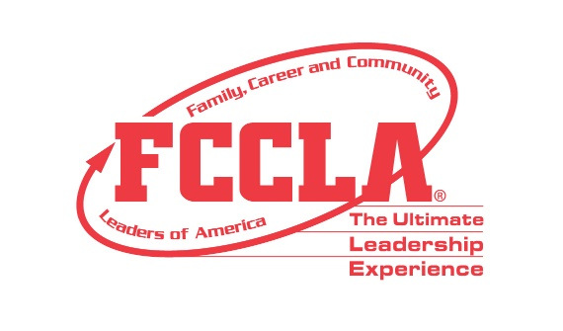310 total attendees from Kansas, representing 117 entries in FCCLA competitive events. Kansas members earned 53 gold medals, 51 silver medals, and seven (7) bronze medals
* Of 117 entries, 50 ranked in the top 10 nationally, with five (5) entries earning 1st in the nation (One (1) from postsecondary), five (5) entries earning 2nd in the nation, and five (5) entries earning 3rd in the nation
* Members ranking first in the nation come from:
  + Mission Valley HS in the Career Investigation event
  + Fredonia Middle School in the Focus on Children event
  + Fredonia HS in the Promote and Publicize FCCLA event
  + Caney Valley Middle School in the Sustainability Challenge event

2024 Membership – 3355 | Chapters - 169

### FFA

National Convention & Expo | October 2024 | Indianapolis, IN

*2023-24 Results*

* 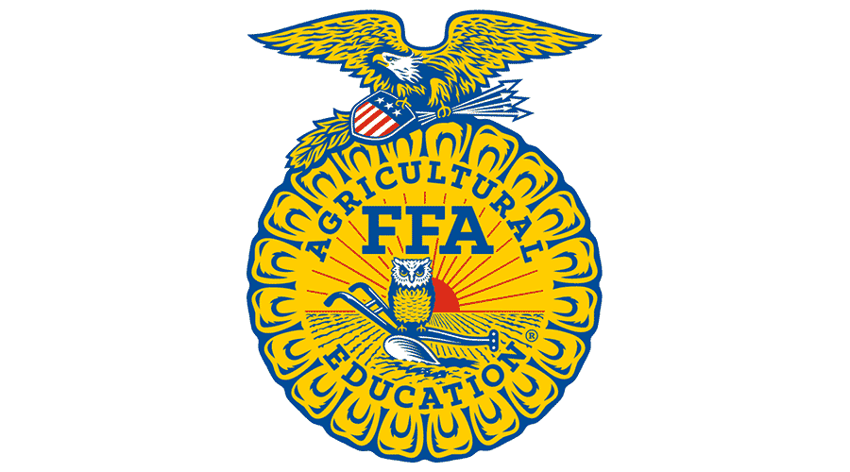195 members from Kansas received more than $238,950 in scholarships from the National FFA Organization and Kansas FFA Association for academics, success in career development events, the opportunity to attend state and national leadership events, and support of their supervised agricultural experience work-based learning programs throughout the 2023-2024 school year
* 332 members were awarded the State FFA Degree at the 96th State FFA Convention. The State FFA Degree is the highest degree that the State FFA Association can bestow on a member. This degree is awarded annually to those members who have met the minimum qualifications set forth by the Kansas FFA Association and National FFA Organization through their involvement in eight or more activities above the chapter level, maintaining their supervised agricultural experience for 24 months, and developing workplace skills.

2024 Membership – 13508 | Chapters 229

### HOSA

International Leadership Conference | June 2024 | Houston, TX

* Recent Kansas graduate was inducted into the HOSA Hall of Fame
* 200 Kansas Members competed.
* Members from Manhattan, Blue Valley, and Great Bend all placed in the top 10 in the nation in events like Medical Innovation, Emotional Well Being Challenge, Medical Assisting, and Phlebotomy

2024 Membership – 1303 | Chapters - 59

### SkillsUSA

National Leadership and Skills Championships Conference | June 2024 | Atlanta, GA

* 80 Kansas Members competed in skilled trades and leadership competitions. Of these members:
  + 29 students received Skill Point Certificates
  + 19 students were awarded medallions (top 3 in the nation)
  + 17 students placed in the top 10 in the nation.
* A student from Manhattan HS earned a gold in Technical Drafting
* A student from Shawnee Mission Center for Academic Achievement earned silver in the Culinary Arts

2024 Membership – 2648 | Chapters - 58

### Technology Student Association (TSA)

National TSA Conference | June 2024 | Orlando, Florida

* Basehor-Linwood HS Member elected as the national president
* Five (5) top 10 in the nation placements in events like CAD Architecture, Coding, and System Control Tech
* Top 10 placing students representing Olathe East HS, Basehor MS, Parson HS, and Junction City HS

2024 Membership – 343 | Chapters 24

### Kansas CTSO State Adviser Contacts

**BPA: Marcy Cross**

*mcross@goddardusd.com*

**DECA: Logan Gauby**

*ksdeca@ksu.edu*

**FBLA: Connie Lindell**

*conniefbla@gmail.com*

**FCCLA: Shandi Andres**

*sdandres@ksu.edu*

**FFA: ~vacant~**

**FFA Executive Secretary: Mary Kane**

*mrkane@ksu.edu*

**HOSA: Tina Goosz Garetson**

[*tgoosz@kumc.edu*](mailto:tgoosz@kumc.edu)

**SkillsUSA: Becky Warren**

[*WarrenB@hutchcc.edu*](mailto:WarrenB@hutchcc.edu)

**TSA: Ruth Delange**

*tsaadministrator@ksde.org*

Membership Total by School Years

2023-2024: 26032

2022-2023: 24856

2021-2022: 23657

2020-2021: 20068

2019‐2020: 23441

2018‐2019: 23555

2017‐2018: 24552

2016‐2017: 23400

2015‐2016: 23666

2014‐2015: 23088

2013‐2014: 23668

2012‐2013: 22794

2011‐2012: 22533

2010‐2011: 22242

2009‐2010: 21708

|  |  |  |
| --- | --- | --- |
| For more information, contact:  Natalie Clark Assistant Director Career, Standards & Assessment Services  (785) 296-4351  [ndclark@ksde.org](mailto:ndclark@ksde.org) |  | Kansas State Department of Education  900 S.W. Jackson Street, Suite 102  Topeka, Kansas 66612-1212  (785) 296-3201  [www.ksde.org](http://www.ksde.org/) |
| The Kansas State Department of Education does not discriminate on the basis of race, color, religion, national origin, sex, disability or age in its programs and activities and provides equal access to the Boy Scouts and other designated youth groups. The following person has been designated to handle inquiries regarding the nondiscrimination policies: KSDE General Counsel, Office of General Counsel, KSDE, Landon State Office Building, 900 S.W. Jackson, Suite 102, Topeka, KS 66612, (785) 296-3201. | | |

JULY 2024